**awsElasticBlockStore Volume:**

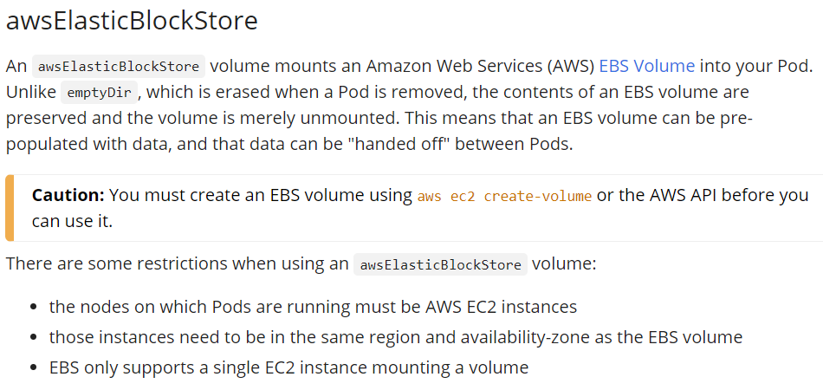

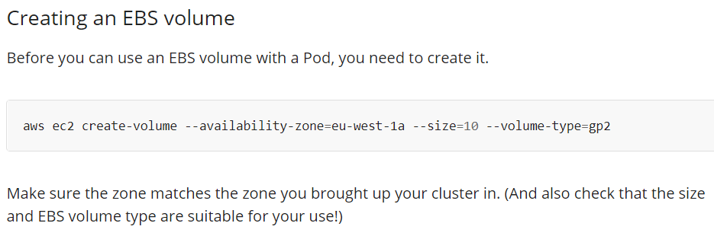

**Yaml file:**

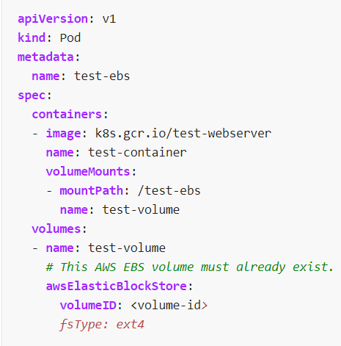

**gcePersistentDisk yaml file:**

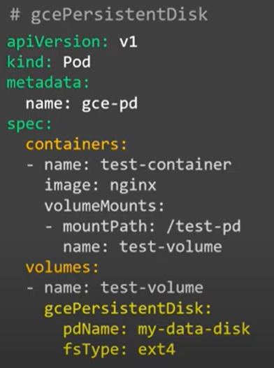

* Describing the same as below.

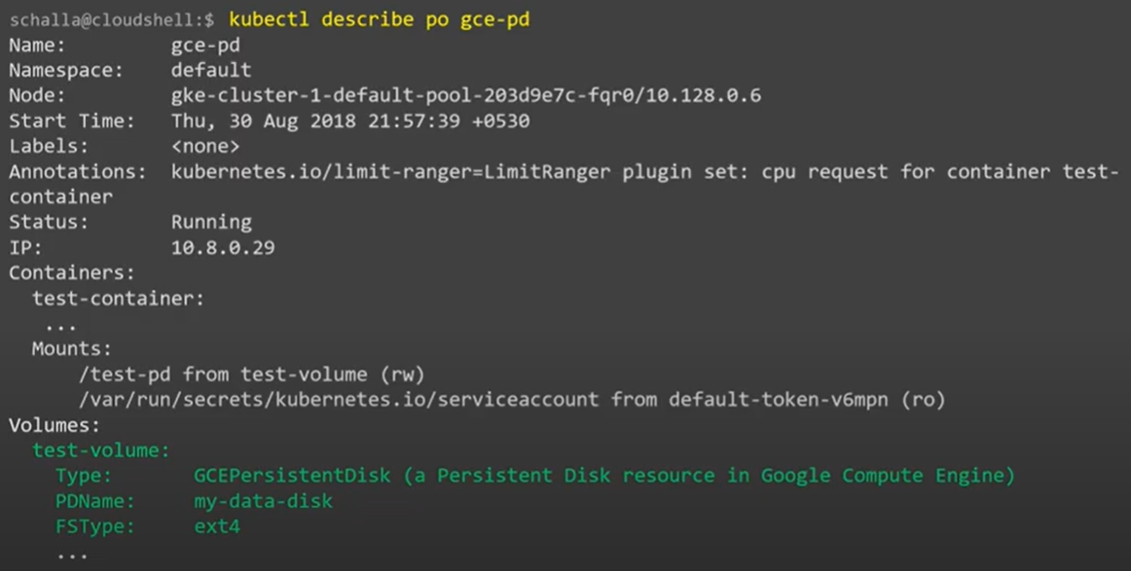

**gcePersistentDisk Test:**

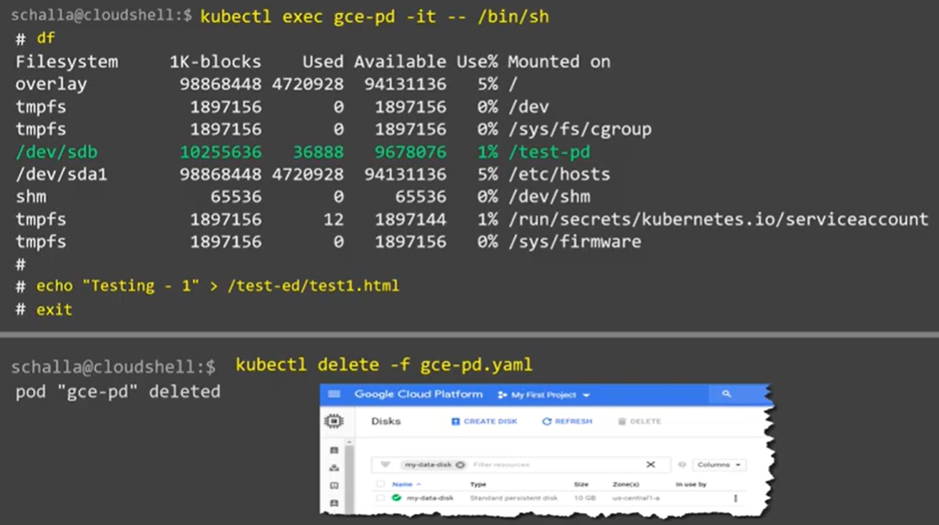

* Now, when we create the new pod with same disk after deleting, we can see the same data in POD again as below.

